Waste Segregation Using Artificial Intellegence Model

Sanjana Jain , Harshit Aggarwal , Anchalesh Patil , Pranav Sharma , Nishant , Anshul Patidar

Abstract - Improper waste separation poses a challenge to recycling and burdens landfills. This paper investigates the potential of artificial intelligence (AI) for improved waste sorting. Machine learning techniques, specifically algorithms like convolutional neural networks, can be trained on image data to recognize various waste materials. By integrating cameras into bins, waste items can be captured and analyzed by the trained AI model for real-time classification and sorting. This approach offers significant improvements over existing methods, including greater accuracy, reduced manual sorting, and the possibility of minimized contamination. The paper explores the technical aspects of AI-based waste sorting, its advantages, and potential hurdles.

1. Introduction - Waste management encompasses the collection, transportation, treatment, and disposal of waste materials [1]. As waste generation rises, efficient and cost-effective disposal and treatment become crucial [2]. Improper segregation of household waste disrupts downstream processing. This paper proposes an approach for efficient waste segregation at the initial collection stage.

1.1 Proposed Solution - We propose a machine learning (ML) based solution for waste segregation. This model utilizes a trained neural network to classify waste items into relevant categories using image recognition.

Sanjana Harshit Anchalesh and Anshul belong to Aerospace dept in Vit Bhopal whereas Nishant is from Ai dept and Pranav is pursuing Core branch

2 . Methodology -

The proposed system involves training a neural network on a dataset of waste images. Logistic regression and binary classification techniques are employed for categorization [3]. The network classifies waste into categories like glass, metal, paper, plastic, and organic materials. The neural network architecture leverages convolutional, pooling, dropout, flatten, and dense layers followed by an activation function for output generation.

Supervised learning guides the model training process. Initially, data collection and augmentation occur. Images are then stored in a 1D array and labeled for model testing.

2.1 Advantages - This approach offers several advantages:

* **Ease of Segregation:** The system simplifies waste segregation for users.
* **Improved Accuracy:** Machine learning provides a high degree of accuracy in classification compared to traditional methods.

3 . Implementation and specification ….

3.1. Importing libraries and checking if CUDA is available –

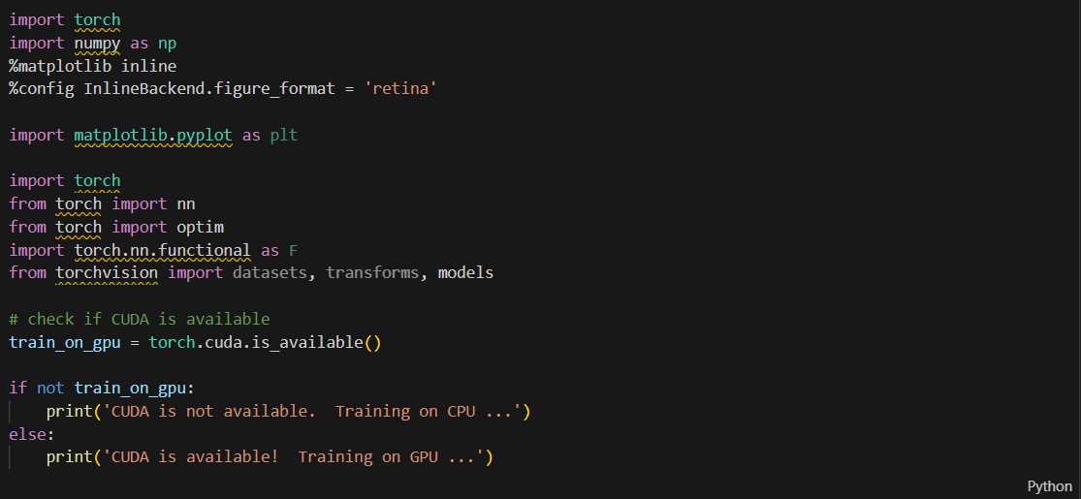

3.2 Data Augmentation –

Data Augmentation is basically cropping, resizing, flipping the image data to get more accurate results. This can be done in PyTorch using transforms. Also, Normalization helps get data within a range and reduces the skewness which helps learn faster and better. Normalization is done in PyTorch by transforms.Normalize wherein two tuples are passed, one tuple has mean for all the three RGB channels followed by the second tuple having standard deviation for all three channels. Data Augmentation is mostly done in training data as it is important to have more accuracy in training so that eventually test accuracy is better. This also increases the amount of training images. Hence, multiple augmentations can be applied on train samples.

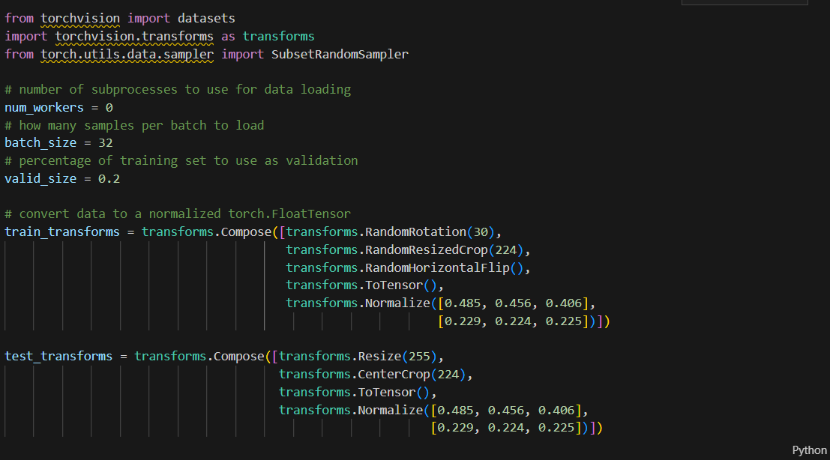

Loading the directories and training and testing data ….

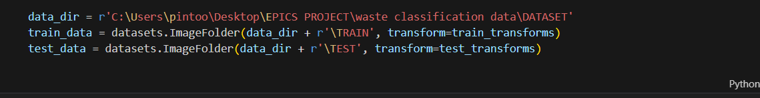

In deep learning, often the training set is split into train samples and validation samples to cross check accuracies. This is done using SubsetRandomSampler.

The DataLoader takes a dataset (such as you would get from ImageFolder) and returns batches of images and the corresponding labels. You can set various parameters like the batch size and if the data is shuffled after each epoch.

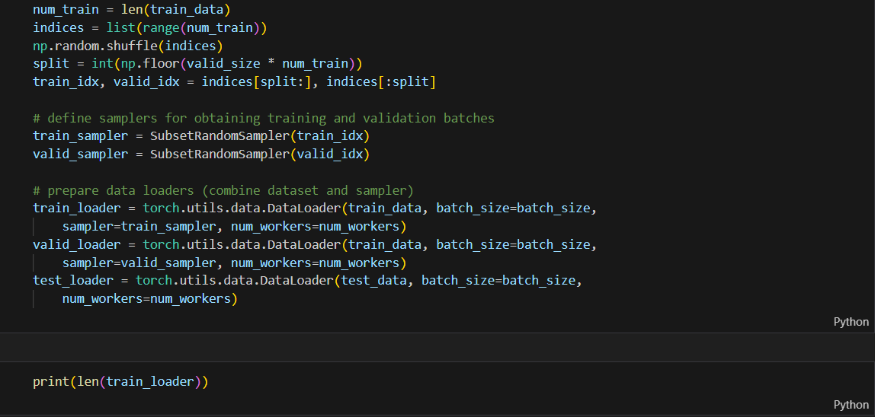

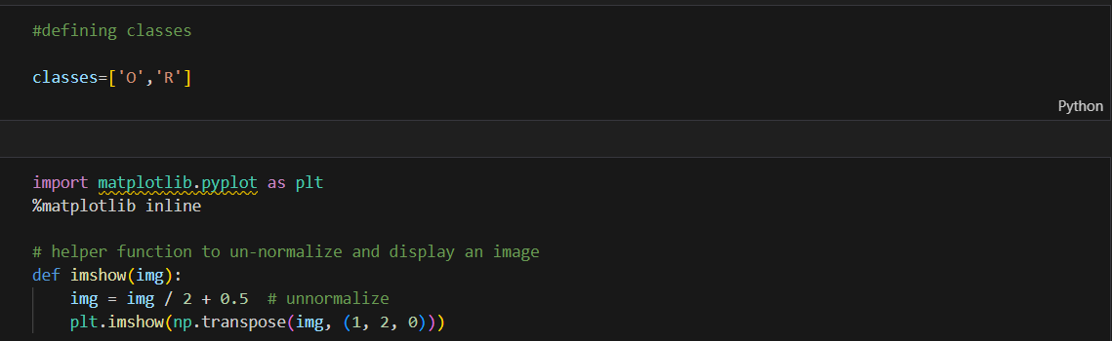

Plotting the image to understand the data O = organic waste , R = reusable waste …

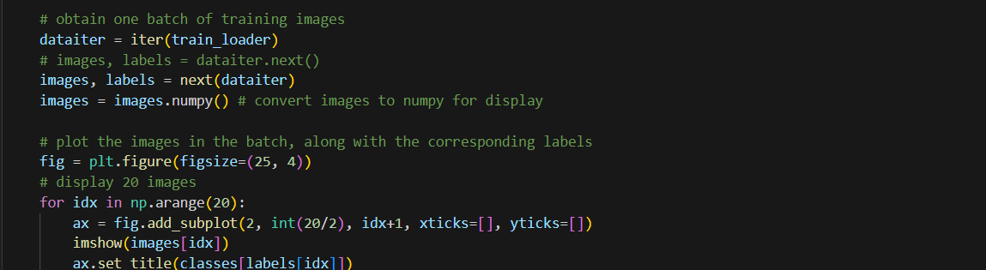

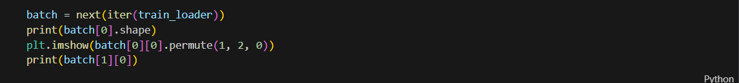

4. Transfer Learning…

Transfer Learning refers to the process of using already existing pre-trained models for other applications by tweaking the last few layers and using it to classify our desired classes. Once trained, these models work astonishingly well as feature detectors for images they weren't trained on. Using a pre-trained network on images not in the training set is called transfer learning. Here we'll use transfer learning to train a network that can classify our organic and recyclable waste photos with near perfect accuracy.

With torchvision models these pre-trained networks can be downloaded and used in applications.

5. DenseNet Architecture model representation ….

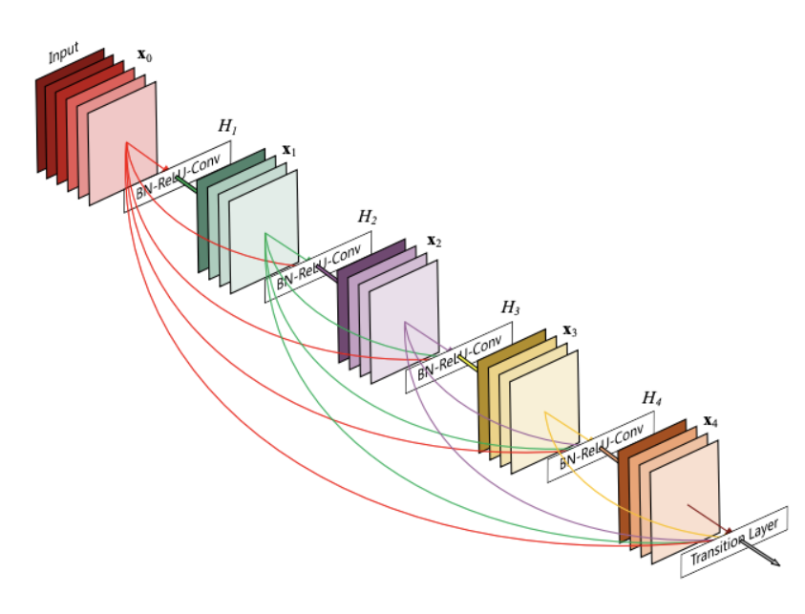

6. Training the model ….

Training the model for desired number of epochs and keeping track of train loss and validation loss. If the validation loss decreases, the model is saved. The simplest thing to do is simply save the state dict with torch. save.

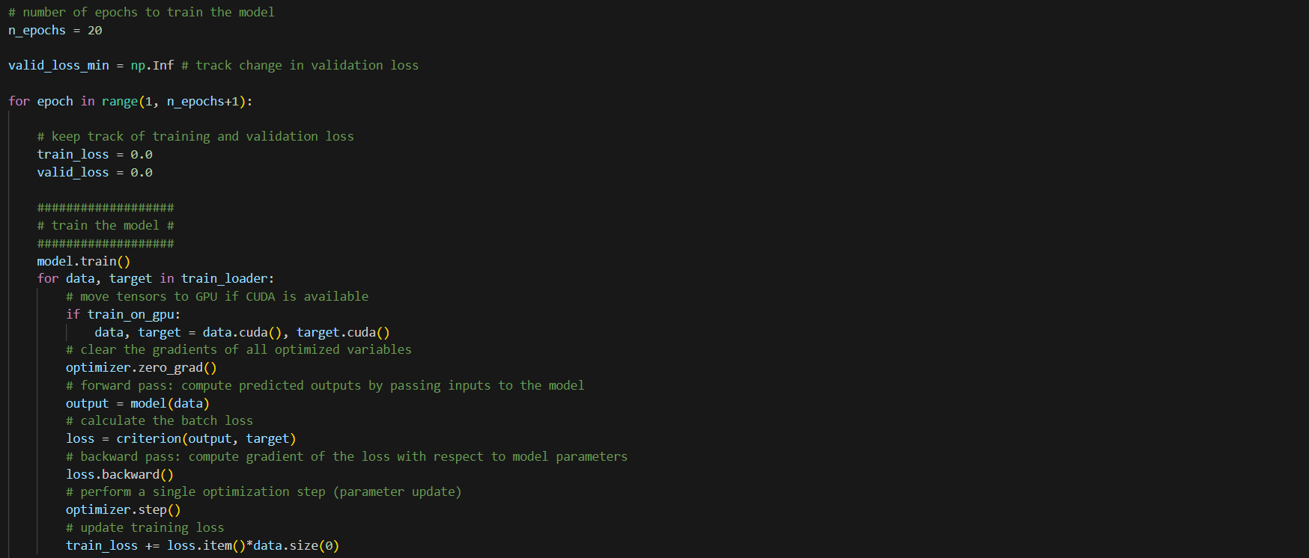

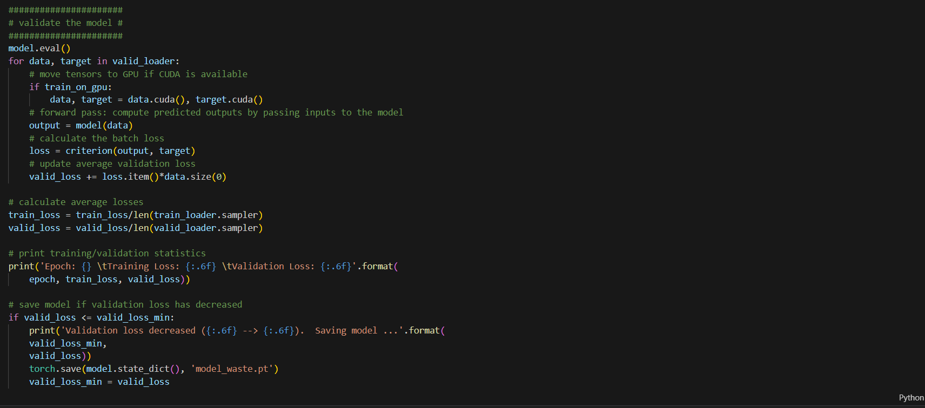

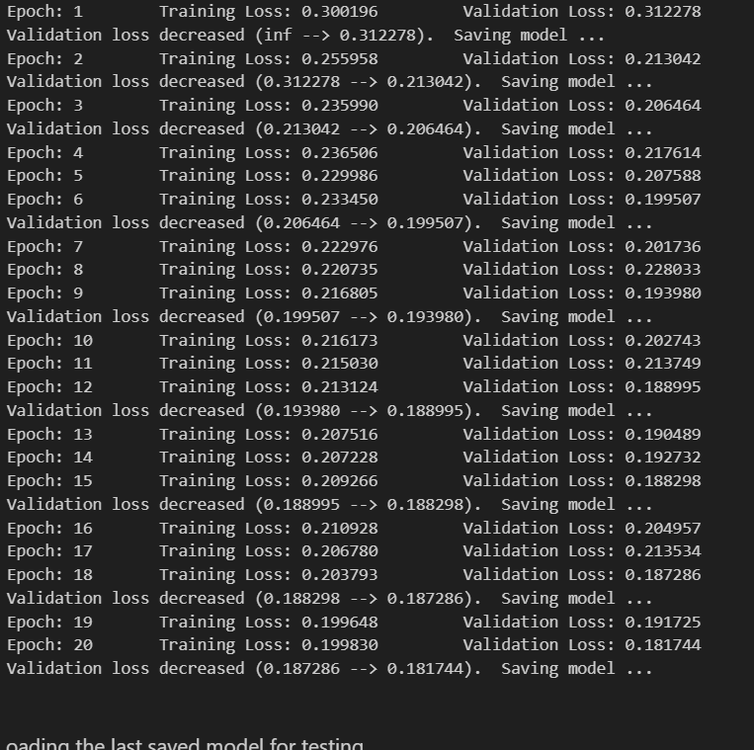

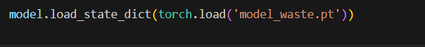

7. Testing the results ….

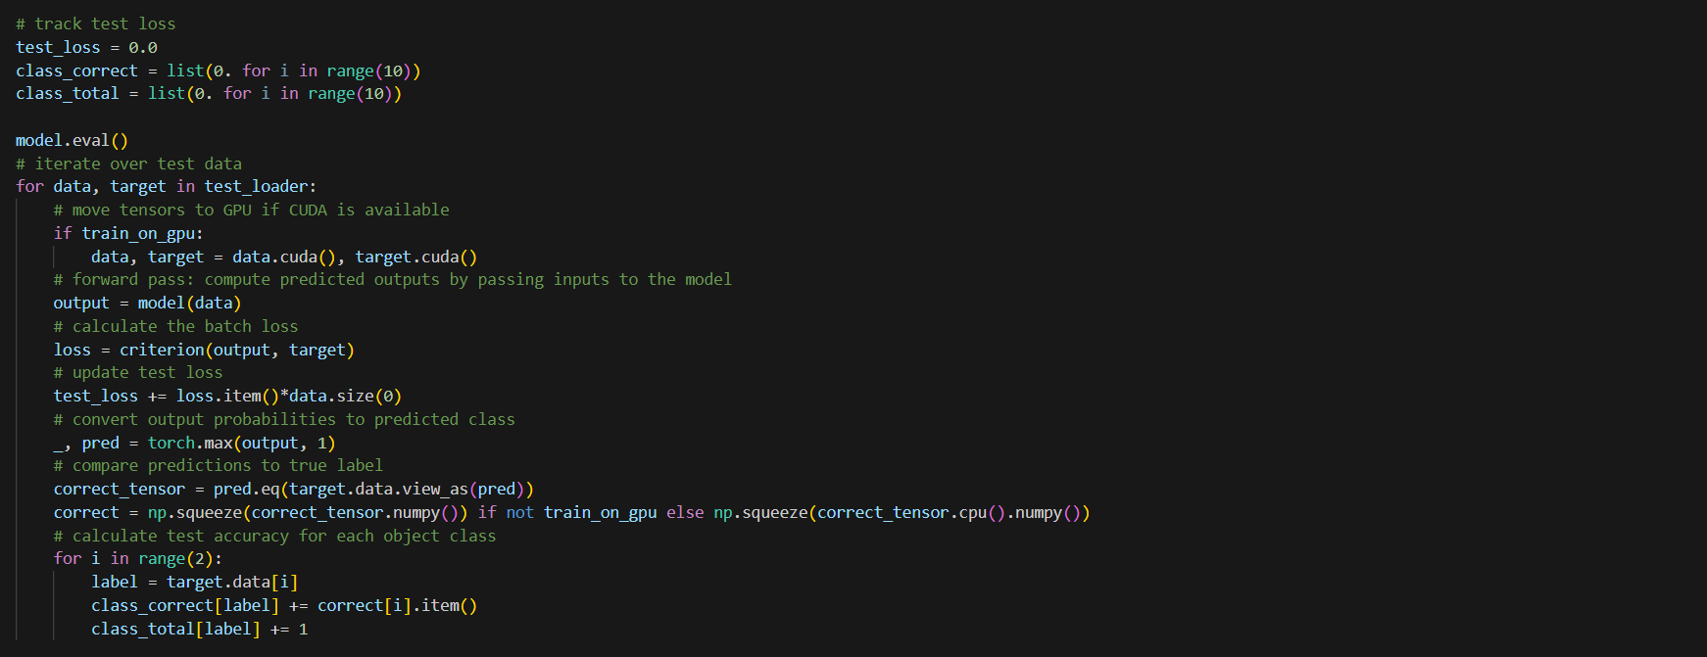

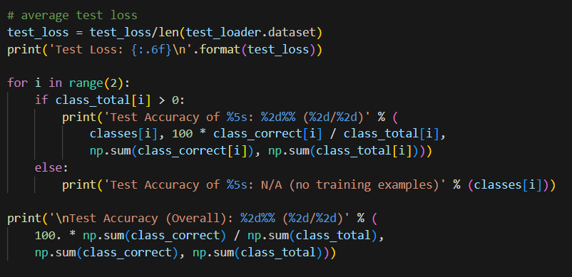

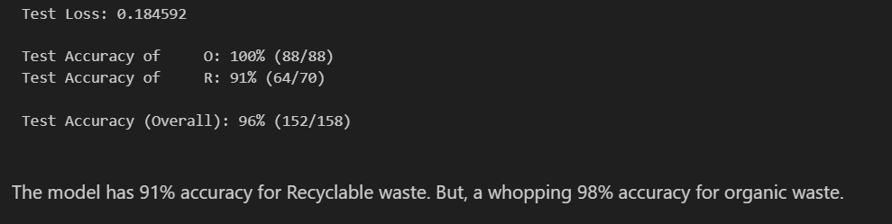

8. Visualizing the result ….

